**Transforming Cyber-Physical Systems: Machine Learning for Secure and Efficient Solutions**

**Harsh Fulambarkar1, Santoshi Kelzarkar 2, Harshita Mirase3, Bhagyashree Kumbhare4, Yamini Kanekar5**

Students, MCA, Smt. Radhikatai Pandav College of Engineering, Nagpur, India1,2,3

HOD, MCA, Smt. Radhikatai Pandav College of Engineering, Nagpur, India4,5

**Abstract:** This study examines the transformative influence of Machine Learning (ML) on Cyber-Physical Systems (CPS), focusing on its contributions to predictive analysis, system enhancement, and safeguarding data. With the growing adoption of CPS in sectors such as transportation, healthcare, and smart infrastructure, ML methods have become crucial for enabling real-time decision-making, identifying anomalies, and optimizing system performance. While the integration of ML offers substantial benefits, it also brings challenges, including vulnerabilities to adversarial threats, concerns about data privacy, and issues related to scalability. This paper provides an in-depth review of ML’s impact on CPS, while proposing potential avenues for future research to mitigate the existing challenges in ML-driven CPS development.

**Keywords:** Machine Learning, Cyber-Physical Systems, Predictive Analytics, Security, Data Privacy, Anomaly Detection, Adversarial Attacks

**I. INTRODUCTION**

Cyber-Physical Systems (CPS) combine real-world physical entities with advanced computational models and communication structures to enable dynamic monitoring and management of physical environments. These systems are revolutionizing fields such as industrial automation, self-driving technologies, and energy management. Machine Learning (ML) is a key enabler within CPS, as it allows the system to analyze extensive datasets, detect underlying trends, and perform autonomous decision-making processes.The rapid evolution of technology has resulted in CPS becoming increasingly prevalent across various sectors, including smart cities and healthcare. The integration of sensors and the Internet of Things (IoT) into these systems enhances data collection capabilities, allowing for more accurate analysis and improved decision-making processes. As a result, industries are experiencing greater operational efficiency and cost savings.

In CPS, ML algorithms enhance system performance by enabling predictive maintenance, optimizing resource usage, and ensuring data security through anomaly detection. However, the convergence of ML with CPS introduces challenges such as model interpretability, ethical concerns, and susceptibility to adversarial attacks, which this paper aims to address.

**Expanding the Scope of CPS Applications**

In addition to the industries mentioned, CPS is extending its reach into agriculture, where real-time data from environmental sensors helps optimize irrigation and crop management systems. ML models are used to predict weather conditions and analyze soil data to improve crop yields while minimizing water usage and other resources. Similarly, in healthcare, CPS-enabled devices, like smart wearable sensors and robotic surgery systems, use ML algorithms to monitor patients' vitals, predict health conditions, and offer personalized treatment.

**Machine Learning’s Impact on System Efficiency**

As CPS becomes more complex and pervasive, ML techniques such as deep learning and reinforcement learning are increasingly employed to manage multi-layered data and optimize system operations. For example, in autonomous vehicles, ML helps integrate data from cameras, radar, and GPS, allowing the system to make decisions on navigation, obstacle avoidance, and safety features in real time. These advancements not only boost efficiency but also lead to cost reductions across sectors by preventing errors, improving resource utilization, and lowering maintenance costs.

**The Importance of Ethical and Interpretability Concerns**

While the benefits of ML in CPS are substantial, they come with risks, particularly regarding the interpretability of complex models and the potential biases inherent in the data used for training. For example, an ML model used in a smart healthcare system could unintentionally favor certain patient demographics based on the historical data it was trained on. Addressing these issues is crucial for ensuring fairness, transparency, and trust in ML-powered CPS systems.

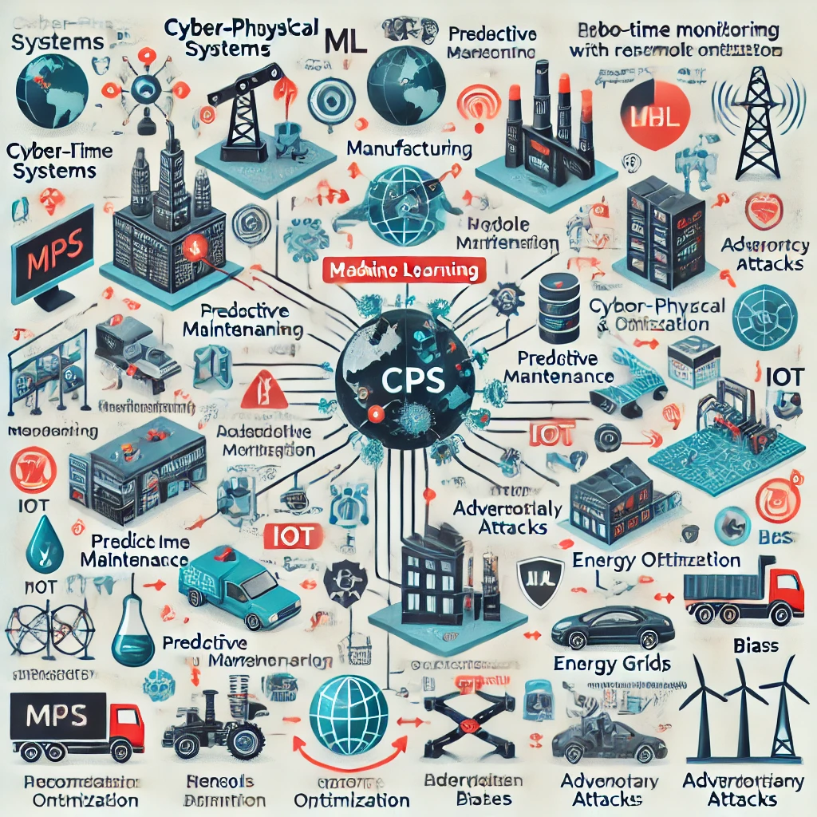

### Fig: Role of Machine Learning in Enhancing Cyber-Physical Systems (CPS)

**II. METHODOLOGY**

This study employs a thorough literature review, case studies, and empirical analysis to examine the intersection of Machine Learning and Cyber-Physical Systems. Different machine learning strategies, such as supervised learning, unsupervised learning, and reinforcement learning, are assessed for their effectiveness in various Cyber-Physical System (CPS) applications. In addition to literature reviews, the study incorporates industry surveys and expert interviews to gather insights on the practical challenges faced during the implementation of ML in CPS. These qualitative methods provide a holistic understanding of the real-world implications and guide future research directions.

Furthermore, this research also delves into the emerging role of federated learning in CPS, which enables decentralized systems to collaboratively learn without sharing raw data. This approach addresses privacy concerns while enhancing the robustness of ML models. Additionally, the study explores the impact of edge computing on reducing latency in CPS applications, allowing faster decision-making and real-time response. Both federated learning and edge computing are identified as critical technologies in advancing the next generation of intelligent CPS, particularly in sectors like healthcare, manufacturing, and transportation. These technologies not only improve efficiency but also provide better scalability, making CPS more adaptable to expanding networks. Moreover, combining these innovations with AI-driven automation will likely push the boundaries of real-time monitoring and predictive capabilities in Cyber-Physical Systems (CPS).

**2.1 Security Threats and Privacy Concerns in CPS**

Cyber-Physical Systems are inherently vulnerable to several types of security risks, including network attacks, software vulnerabilities, and physical manipulation. ML techniques offer potential solutions to these risks by enabling systems to detect and prevent intrusions, analyze network behavior, and secure sensitive data.

* **Network Threats**: Frequently encountered vulnerabilities in networks consist of unauthorized access, breaches of data security, and denial-of-service attacks. ML-based network intrusion detection systems (NIDS) use real-time data to identify suspicious activities and mitigate risks.
* **ML-Based Threats**: ML models deployed in CPS are susceptible to adversarial attacks, where malicious inputs can cause the system to behave unpredictably. Defending ML models in CPS requires continuous model monitoring and retraining.

As the threat landscape continues to evolve, it is crucial to develop adaptive security measures that can respond to new and unforeseen risks. Research into automated threat detection and response systems powered by machine learning can enhance the resilience of CPS against emerging threats. By continually updating and training models based on new data, these systems can maintain high levels of security.

**2.2 ML Techniques in Threat Detection**

Machine learning models are essential for detecting threats in Cyber-Physical System environments. Methods such as clustering (unsupervised learning), classification (supervised learning), and reinforcement learning are utilized to identify anomalies, foresee failures, and protect systems from potential attacks. Advanced ML techniques, including deep learning and ensemble methods, provide enhanced accuracy in threat detection. By leveraging large datasets and complex algorithms, these techniques can discern subtle patterns in data that traditional methods may overlook, resulting in more reliable detection of potential threats.

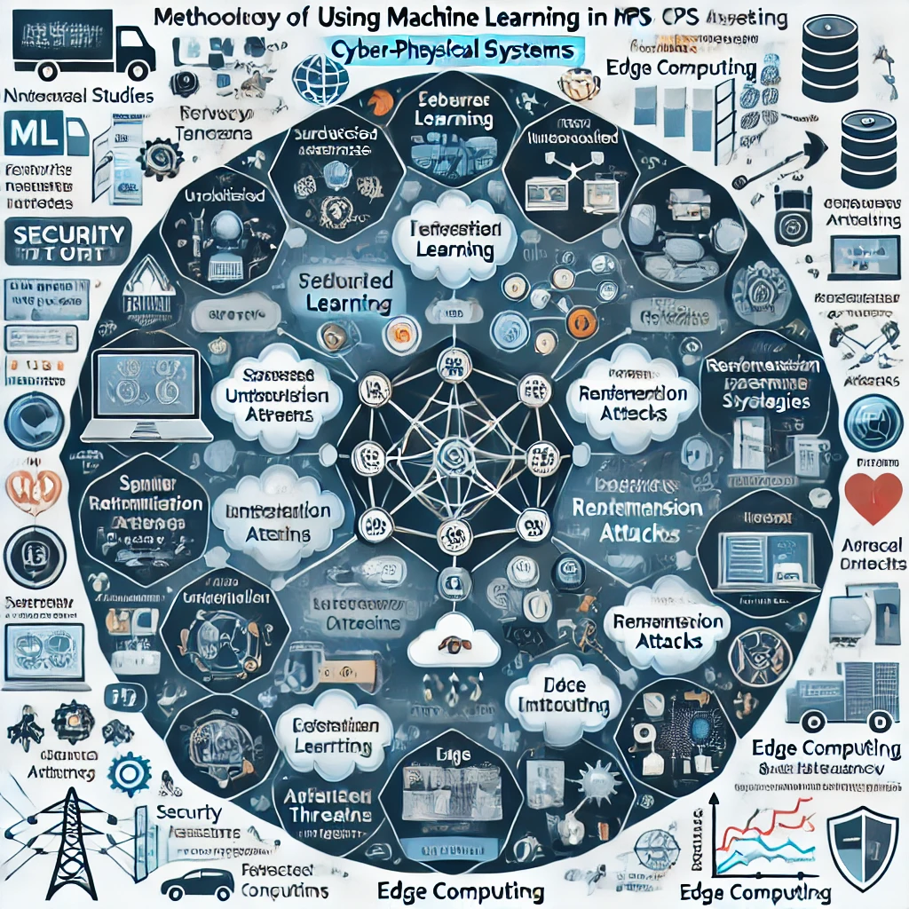

**Fig: Methodological Aspects of Integrating Machine Learning into CPS Security**

**III. CASE STUDIES**

**3.1 Predictive Traffic Management Systems**

Machine learning algorithms are employed by predictive traffic management systems to dynamically regulate traffic flow in real-time, helping to ease congestion and enhance safety. By analyzing traffic data collected from sensors embedded in roads and vehicles, ML models predict traffic patterns and recommend optimized traffic signal timings. Successful implementations of predictive traffic management systems have demonstrated a marked decrease in traffic congestion and improved response times for emergency vehicles. These systems not only benefit individual users but also contribute to overall urban efficiency and environmental sustainability by reducing emissions and fuel consumption.

**Key Benefits**:

* A decrease in both traffic congestion and emissions.
* Improved road safety through predictive analytics
* Better resource allocation in real-time

**3.2 ML-Based Predictive Maintenance in Manufacturing**

Predictive maintenance in manufacturing is facilitated by machine learning models that analyze sensor data from machinery. These models can forecast potential equipment failures, enabling preventive repairs to minimize downtime and lower operational costs. The effectiveness of predictive maintenance has been validated in several case studies across different manufacturing sectors, revealing substantial reductions in unplanned downtime and maintenance costs. As a result, manufacturers are adopting these technologies to enhance operational efficiency and maintain a competitive edge in the market.

**Key Benefits**:

* Reduced machine downtime and improved operational efficiency
* Cost-effective maintenance scheduling based on real-time analytics
* Increased lifespan of equipment through early fault detection

**3.3 Machine Learning in Energy Management for Smart Grids**

Machine learning models in smart grid systems analyze data collected from smart meters and sensors to predict energy needs and enhance distribution efficiency. ML-based load forecasting helps balance energy production and consumption, while also integrating renewable energy sources. The successful application of machine learning in energy management has resulted in smarter energy consumption patterns and improved integration of renewable energy. Smart grids that leverage Machine learning can adjust dynamically to fluctuating energy demands, thus enhancing reliability and reducing costs for consumers and providers alike.  Additionally, Machine learning enables grid operators to make proactive adjustments based on weather patterns, usage trends, and equipment performance. By automating decision-making processes, machine learning reduces the need for manual intervention and increases overall grid resilience. This also helps improve long-term grid planning by predicting peak loads and potential faults more accurately. The integration of real-time data analytics through Machine learning further ensures optimal energy distribution, minimizing outages and improving sustainability. This dynamic adjustment supports operational savings and drives future innovations in energy management.

**Key Benefits**:

* Enhanced energy efficiency and reduced operational costs
* Enhanced incorporation of renewable energy sources.
* Instantaneous prediction and regulation of energy demand.

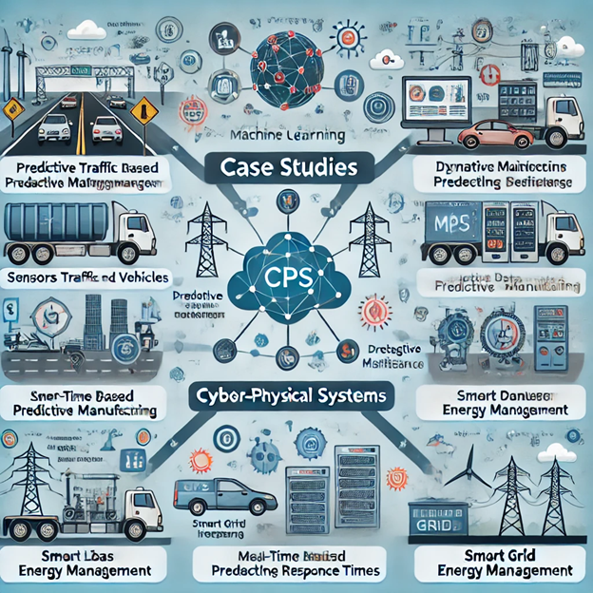

**Fig: Case Studies in Cyber-Physical Systems Utilizing Machine Learning**

**IV. CHALLENGES AND LIMITATIONS**

**4.1 Data Collection and Quality**

The performance of machine learning models is largely influenced by both the amount and the quality of the data used. In CPS environments, obtaining high-quality data is often challenging due to noise, missing values, or incomplete data from sensors. Without clean data, ML models may produce inaccurate results.

Addressing data quality issues is essential for ensuring the reliability of ML applications in CPS. Strategies such as implementing robust data preprocessing techniques and utilizing advanced filtering methods can enhance the quality of the input data, thereby improving model performance.

**4.2 Integration Complexity**

Integrating ML models into existing CPS infrastructure can be difficult, especially when retrofitting older systems with new technology. Compatibility issues may arise, requiring significant changes to hardware and software, as well as rethinking data pipelines and processing capabilities.

To mitigate integration challenges, organizations should consider adopting modular architectures that allow for easier incorporation of new technologies. This approach not only facilitates smoother transitions but also enables incremental upgrades to existing systems without the need for complete overhauls.

**4.3 Ethical and Privacy Concerns**

The deployment of ML in CPS raises several ethical issues, particularly with respect to data privacy and bias. Machine learning algorithms, when not carefully constructed, can unintentionally embed bias into decision-making processes. Moreover, ensuring data privacy while leveraging sensitive information for predictive analysis is a constant challenge.

Developing ethical frameworks and guidelines for the deployment of machine learning in CPS is essential to address these concerns. Such frameworks should focus on transparency in algorithm development and accountability in decision-making processes, ensuring that ML applications align with societal values and ethical standards.

**4.4 Adversarial Attacks**

ML models used in CPS are vulnerable to adversarial attacks. Attackers may introduce subtle modifications to input data, causing the ML model to make incorrect predictions. A significant challenge for the future of CPS is building strong machine learning models that can withstand these types of attacks.

Research into adversarial machine learning techniques is critical for developing robust systems that can detect and defend against such attacks. By creating models that can learn from adversarial examples, researchers can enhance the resilience of CPS against potential threats.

**4.5 Scalability and Generalization**

One of the biggest limitations of applying ML to CPS is the issue of scalability. Each CPS environment is unique, and a model that works well in one context may not generalize to another. Ensuring that ML models can be scaled effectively across different CPS applications remains a significant challenge.

Utilizing transfer learning strategies can help improve the scalability of ML models. By leveraging knowledge gained from one task to inform another, organizations can expedite the deployment of ML solutions across various CPS environments, ultimately leading to greater efficiency and reduced costs.

**V. FUTURE DIRECTIONS**

**5.1 Advanced ML Techniques for Security**

Current ML models can detect anomalies and predict system failures with reasonable accuracy, but more advanced techniques, such as deep learning and reinforcement learning, have the potential to further improve CPS performance. Future research should focus on implementing these advanced techniques for real-time threat detection and predictive control. Exploring hybrid models that combine various ML approaches may yield superior outcomes in security applications. By harnessing the strengths of different algorithms, researchers can create more robust and versatile systems capable of addressing complex challenges.

**5.2 Privacy-Preserving Machine Learning**

As data privacy concerns continue to rise, the demand for privacy-preserving machine learning methods like federated learning and differential privacy is increasing. These methods allow systems to analyze data while maintaining the privacy of sensitive information, making them ideal for CPS that handle personal data. The advancement of encryption techniques and secure multi-party computation can further enhance data privacy. Integrating these technologies into ML workflows will help protect sensitive information while allowing organizations to benefit from data insights.

**5.3 Robustness Against Adversarial Attacks**

Developing adversarially robust ML models is an important area of future research. Methods such as adversarial training, which involves training models on adversarial samples, and defensive distillation are useful for strengthening the resilience of machine learning systems against attacks. The use of adversarial examples during training serves to strengthen model robustness by enriching the data provided to the model. This proactive approach to model training can help mitigate the risk of successful attacks.

**5.4 Real-World Validation of ML Models in CPS**

While theoretical studies and simulations provide valuable insights, real-world implementations of ML models in CPS are necessary for assessing their practical effectiveness. Collaborations between industry and academia can facilitate the deployment of ML-based CPS solutions and validate their performance in live settings. Establishing partnerships between academia, industry, and government can facilitate knowledge exchange and drive innovation in CPS research. Joint initiatives can promote the development of ethical guidelines, standards, and best practices for deploying ML technologies.

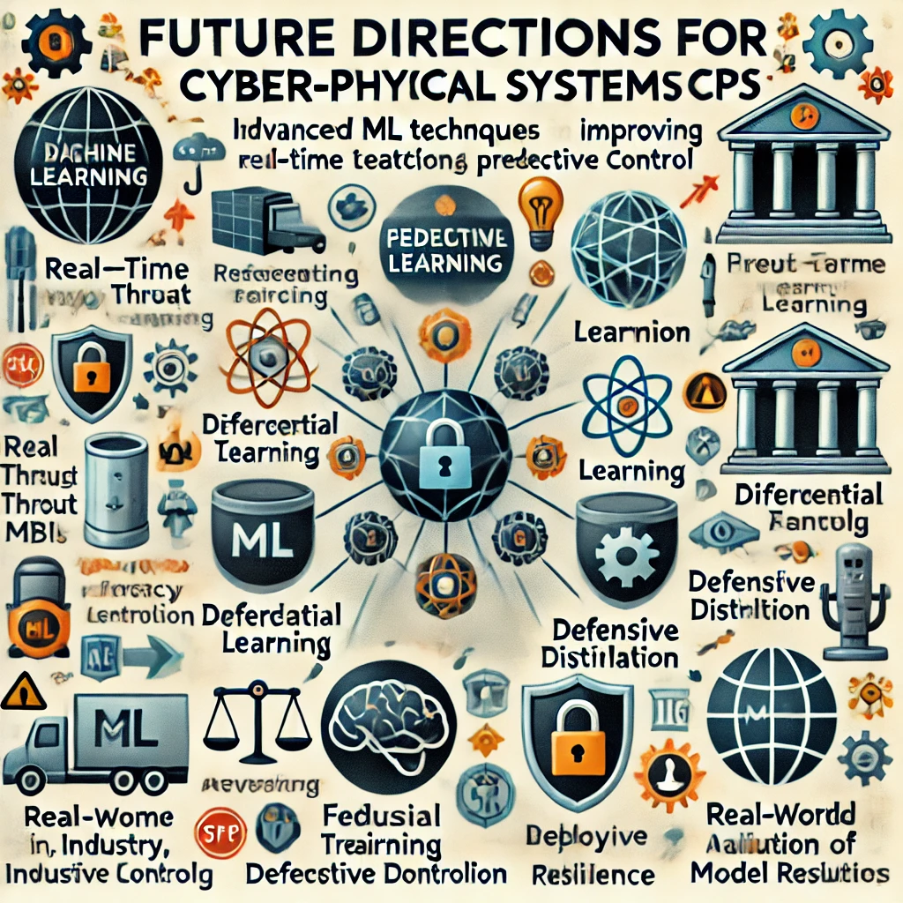

**Fig: Machine Learning-Driven Innovations in Cyber-Physical Systems (CPS)**

**VI. CONCLUSION**

Machine Learning has significantly enhanced the capabilities of Cyber-Physical Systems, enabling them to make real-time decisions, detect anomalies, and predict failures. By leveraging ML techniques, CPS can become more efficient, secure, and adaptive to changing environments. However, the integration of ML into CPS also presents several challenges, including data privacy concerns, adversarial threats, and integration complexity. Addressing these challenges through advanced ML techniques, privacy-preserving methods, and robust security frameworks will be critical to the future success of ML-powered CPS.

Ensuring the scalability of ML models across diverse CPS environments is another crucial aspect that must be addressed. As each CPS presents unique operational contexts, solutions that work in one environment may not easily transfer to others without significant adaptation. This calls for the development of more generalized and flexible ML algorithms that can effectively operate across different systems. Furthermore, the real-time nature of CPS necessitates the continuous updating and retraining of ML models to respond to evolving threats and operational conditions. Therefore, future research should focus on building self-adaptive and autonomous learning systems that can maintain high levels of performance without human intervention.

he ethical and societal implications of widespread ML use in CPS must not be overlooked. Data privacy concerns, model transparency, and the potential for biased decision-making are ongoing issues that require careful consideration. Advancing CPS will require not only technical innovation but also rigorous attention to ethics and governance to ensure that these systems are deployed safely and responsibly.

Looking forward, the evolution of ML-powered CPS will likely benefit from advancements in quantum computing and edge AI. Quantum computing could significantly boost the processing power available to CPS, enabling the analysis of much larger datasets in real time, while edge AI allows for decentralized processing closer to data sources, minimizing latency and enhancing decision-making speed. Both technologies promise to further expand the potential of CPS, opening new avenues for smarter, more responsive systems that are even more integrated into critical infrastructures across industries.

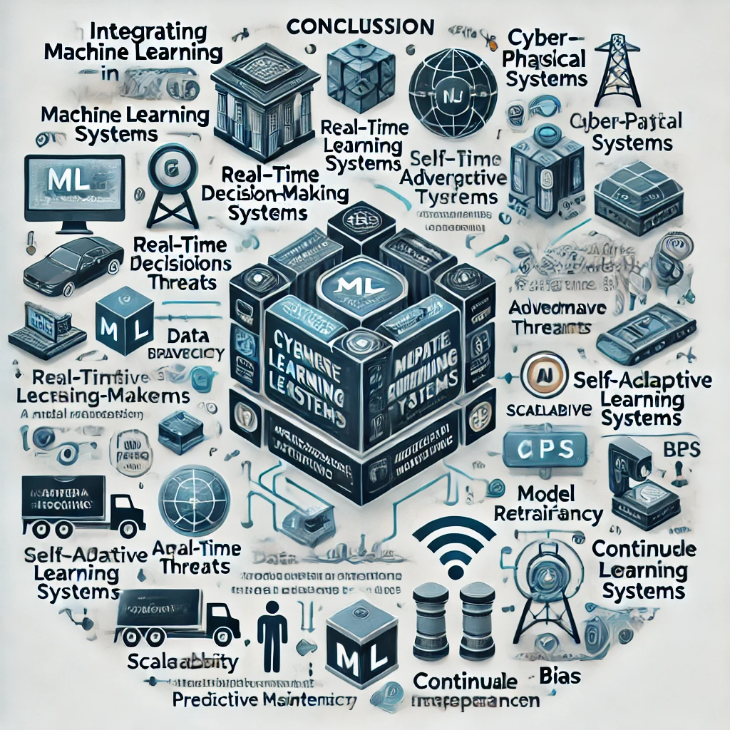

**Fig: The Role of Machine Learning in Enhancing Decision-Making**

**REFERENCES**

1. Edward A. Lee and S. Shankar Sastry, Introduction to Cyber-Physical Systems, published by Springer in 2015.
2. Xiaobo Xue and colleagues authored 'A Survey on Machine Learning Techniques in Cyber-Physical Systems,' which was published in Computers & Electrical Engineering, volume 72, in 2019, spanning pages 1 to 13.
3. Tingting Wang and co-authors published a comprehensive survey titled 'Cyber-Physical Systems Security.' IEEE Internet of Things Journal, vol. 7, no. 7, 2020, pp. 6327-6344.
4. Li, Zhiwu, et al. "An Overview of the Applications of Machine Learning in Cyber-Physical Systems." IEEE Access, vol. 7, 2019, pp. 17615-17627.
5. S. A. A. Bakar, N. H. M. Yusof, and N. F. Abdul Aziz, "A Comprehensive Review of Machine Learning Algorithms in Cyber-Physical Systems," Journal of King Saud University - Computer and Information Sciences, vol. 34, no. 4, pp. 913-924, 2022.
6. M. F. A. Z. Abidin, S. A. M. S. Zain, and R. A. Bakar presented a survey titled 'Data-Driven Approaches for Cyber-Physical Systems: A Survey on Machine Learning Techniques' in Future Generation Computer Systems, volume 114, pages 659-671, published in 2021.
7. In the article 'A Survey on Machine Learning for Cyber-Physical Systems: Challenges and Future Directions,'. Y. Zhang, C. Zhao and M. Huang discusses various challenges and future directions in IEEE Transactions on Industrial Informatics, volume 16, number 7, pages 4695-4704, from 2020."
8. R. A. F. De Oliveira, E. R. C. da Silva, and E. H. de Andrade authored a comprehensive survey on 'Deep Learning in Cyber-Physical Systems,' published in IEEE Internet of Things Journal, volume 8, issue 4, pages 3005-3021, in 2021.
9. H. B. H. Hu, Y. F. Chen, and J. B. He, "Machine Learning-Based Data Analytics for Cyber-Physical Systems: Applications and Challenges," ACM Computing Surveys, vol. 53, no. 3, pp. 1-38, 2021.
10. R. K. Jha, D. L. O. Ayoob, and M. L. Chowdhury reviewed adversarial machine learning applications in cyber-physical systems in the paper titled 'Adversarial Machine Learning in Cyber-Physical Systems: A Review,' published in Sensors, volume 21, issue 3, in 2021.